**DB Lab Manual 1:**

Roll Number: 21L-1858

Name: Umamah Hussain

Section: BSCS-C

Queries:

create table Student

(

Rollnum nvarchar(255) primary key,

Names varchar(255),

Gender varchar(255),

Phone nvarchar(255)

);

create table Teacher

(

ID int primary key,

Names varchar(255),

Designation varchar(255),

Department nvarchar(255)

);

create table ClassVenue

(

ID int primary key,

Building varchar(255),

RoomNum int,

TeacherID int

);

create table Attendance

(

Rollnum varchar(255) primary key,

Dates varchar(255),

Stattus varchar(255),

ClassVenue varchar(255)

);

Insert into Attendance([Rollnum],[Dates],[Stattus],[ClassVenue])

values

('L164123','2-22-2016','P','2'),

('L164124','2-23-2016','A','1'),

('L164125','3-4-2016','P','2')

Insert into Student([Rollnum],[Names],[Gender],[Phone])

values

('L161423','Ali Ahmad','Male','0333-3333333'),

('L164124','Rafia Ahmad','Female','0333-3456789'),

('L164125','Basit Junaid','Male','0345-3243567')

Insert into ClassVenue([ID],[Building],[RoomNum],[TeacherID])

values

(1,'CS',2,1),

(2,'Civil',7,2)

Insert into Teacher([ID],[Names],[Designation],[Department])

values

(1,'Ali Ahmad','Assisstant Prof','Computer Science'),

(2,'Rafia Ahmad','Lecturer','Civil Eng'),

(3,'Bilal Haider','Professor','Electrical Eng')

select* from Student

select* from Teacher

select* from Attendance

select* from ClassVenue

Student:

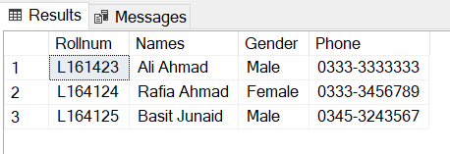

Teacher:

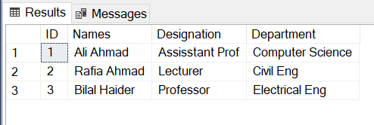

Attendance:

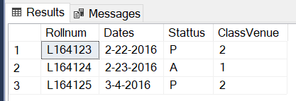

Class Venue:

